Exercise 2: E-Commerce Platform Search Function

Understanding Asymptotic Notation
Big O Notation is used to measure the performance of an algorithm as the input size increases.
Search Cases
- Best Case: Element found immediately → O(1)
- Average Case: Element found in the middle → O(n)
- Worst Case: Element found at the end or not present → O(n)

Implementation
class Product {
int productId;
String productName;
String category;
Product(int productId, String productName, String category) {
this.productId = productId;
this.productName = productName;
this.category = category;
}
void display() {
System.out.println("ID: " + productId);
System.out.println("Name: " + productName);
System.out.println("Category: " + category);
}
}
public class dsa {
static Product linearSearch(Product[] products, int targetId) {
for (int i = 0; i < products.length; i++) {
if (products[i].productId == targetId) {
return products[i];
}
}
return null;
}
static Product binarySearch(Product[] products, int targetId) {
int l = 0;
int h = products.length - 1;
while (l <= h) {
int m = (l + h) / 2;
if (products[m].productId == targetId) {
return products[m];
}
if (products[m].productId < targetId) {
l = m + 1;
} else {
h = m - 1;
}
}
return null;
}
public static void main(String[] args) {
Product[] products = {
new Product(201, "Headphones", "Electronics"),
new Product(202, "Backpack", "Travel"),
new Product(203, "Notebook", "Stationery"),
new Product(204, "Water Bottle", "Lifestyle"),
new Product(205, "Smart Watch", "Gadgets")
};
int searchId = 204;
System.out.println("Searching Using Linear Search");
Product result1 = linearSearch(products, searchId);
if (result1 != null) {
result1.display();
} else {
System.out.println("Item Not Available");
}
System.out.println();
System.out.println("Searching Using Binary Search");
Product result2 = binarySearch(products, searchId);
if (result2 != null) {
result2.display();
} else {
System.out.println("Item Not Available");
}
}
}

Output
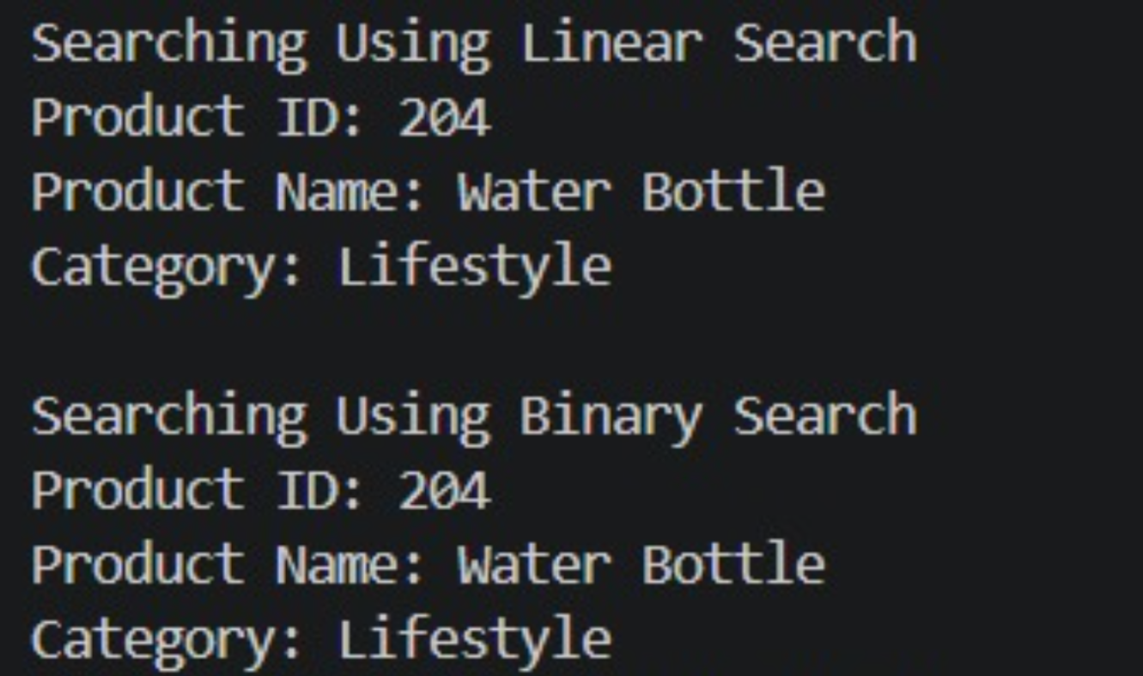

Analysis
Algorithm | Best Case | Average Case | Worst Case
Linear Search | O(1) | O(n) | O(n)
Binary Search | O(1) | O(log n) | O(log n)

Conclusion
Linear Search checks products one by one, whereas Binary Search divides the search space into halves. Therefore, Binary Search is more efficient for large product datasets.

Exercise 7: Financial Forecasting

Understanding Recursive Algorithms
Recursion is a programming technique where a method calls itself to solve a problem. It simplifies complex problems by breaking them into smaller subproblems.

Implementation
public class prav2 {
static double calculateAmount(double amount, double rate, int period) {
if (period == 0) {
return amount;
}
return calculateAmount(
amount * (1 + rate),
rate,
period - 1
);
}
public static void main(String[] args) {
double initialAmount = 15000;
double growthRate = 0.08;
int years = 4;
double predictedAmount = calculateAmount(initialAmount, growthRate, years);
System.out.println("Estimated Amount after " + years + " years : " + predictedAmount + "/-");
}
}

Output

Analysis

Time Complexity
The recursive function makes one recursive call for each year.
Time Complexity: O(n)

Optimization
The recursive solution can be optimized using:
- Memoization
- Dynamic Programming
These techniques reduce repeated computations and improve performance.

Conclusion
The recursive algorithm successfully predicts the future amount based on a fixed growth rate. It is simple to implement and demonstrates the concept of recursion effectively.

